## Big Mountain Ski Resort Adult Lift Ticket Price Analysis and Recommendation

**Recommendation**

* Based on the assumptions and competitive analysis gathered, my recommendation is to increase both Adult Weekend and Adult Weekday prices to $88 per ticker

**Model description and assumptions**

* Our pricing model performed a competitive pricing analysis of 330 ski resorts and took 27 key resort attributes into account to assess the feasibility of increasing Big Mountain Resort's lift tickets.
* The predictive model used standard linear regression to predict the **Adult Weekend Lift Ticket Price** (Y variable) using all other resort attributes provided by our database manager – except for resort state and region – as the dependent X variables.
* The model concluded that the top 10 factors in price were:
  1. AdultWeekday Price *
  2. summit_elev
  3. base_elev
  4. vertical_drop
  5. averageSnowFall
  6. quad
  7. triple
  8. surface
  9. daysOpenLastYear
  10. total runs

* Adult Weekday price’s high correlation was to be expected as there is a nearly perfect 1:1 linear relationship with the Weekend price.

**Recommendation and Supporting Scatter Plots**

* Based on the model assumptions, using a linear regression model, we feel that we can increase our Adult Weekend Price from **$81 to $88 for the upcoming season**
* In order to ensure that our increased prices are reasonable and will not put us at a competitive disadvantage I have plotted how our current $81 price and suggested $88 price compare to similarly structured resorts in the data set.
* The 330 Resorts were split into 3 subgroups using a k-means clustering algorithm and are color coded in each of the following charts. Big Mountain belongs to the “purple cluster”. ‘
* The following 3 scatter plots represent the top 5 correlated attributes relative to Adult Weekend Price
  1. Adult Weekday price was excluded from the top 5 list as we know this is a simple 1:1 relationship
  2. The summit elevation, base elevation, and vertical drop were combined into one chart using the average of all three attributes along the y axis
  3. Adult Weekend prices are on the x axis in each chart
  4. The **large red dot represents our current price** while the **blue dot represents the suggested price**

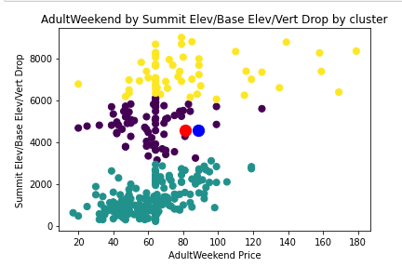

* **Red Dot** represents $81 current lift ticket price
* **Blue Dot** represents $88 suggested lift ticket price
* Big Mountain Resort belongs to the *purple*  cluster

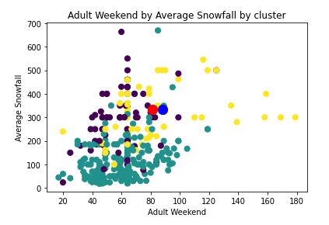

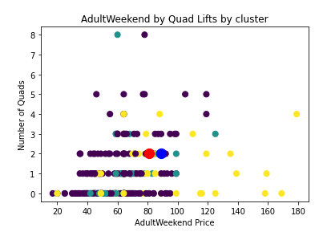

**Conclusion and Final Notes**

1. The three charts conclude that when measured by the top 5 indicators of price relative to the competitive set, the $88 price point is reasonable in the median range of all resorts and still lies within a reasonable range of Big Mountain’s respective *purple* cluster
2. The models error scores for reference are listed below:

| **Metric** | **Score** |
| --- | --- |
| RMSE | 7.59 | |
| MAE | 5.72 | |
| EVS | 0.91 | |

1. Based on the analysis above, I also recommend increasing the **Adult Weekday price from $81 to $88**. The summary statistics and box plot on the next page indicate that there is little variability between Weekday and Weekend prices for cluster 2 resorts. The average Weekend premium is 4.3% over the Weekday price, however most resorts have no difference between the two.

